CONTENTS – SECTION 1
LESSON 1 INTRODUCTIONS
LESSON 2 GREETINGS
LESSON 3 OBJECTS
LESSON 4 VISITING A FRIEND’S HOUSE
LESSON 5 MY THINGS
LESSON 6 CITIES AND TOWNS; COUNTRIES & CITIZENSHIP
LESSON 7 MY FAMILY
LESSON 8 OUR HOUSE

LESSON 7 MY FAMILY
OBJECTIVES
- Be able to describe about people’s relationships.
- Be able to ask and refer relationships.
- Be able to describe clothing.
- Be able to ask and refer to one’s clothing and describe physical/emotional traits.
- Be able to understand the use of NA as a relative pronoun.
- Be able to use AT & PERO as conjunctions.
- Be able to differ MAG & IN Conjugation and their functions.

Lesson 7 Phrases
- Ito ang nanay ko. Margarita ang pangalan niya. = This is my mom. Margarita is her name.
- Meron silang alagang pusa. = They have a pet cat.
- Ano ang suot niya? = What is she wearing?
- Nakasuot siya ng pulang sumbrero. = He is wearing a red hat.
- Si Ben ang nakasuot ng pulang sumbrero. = Be is the one who is wearing a red hat.
- Si Maria ay isang batang malungkutin. = Maria is an always sad child.

Lesson 7 Vocabularies Relationship and Clothes
Asawa = Husband/Wife Kamag-anak = Relatives Polo = Shirt
Magulang = Parent Ka-opisina = Office staff Kurbata = Tie
Anak = Son/Daughter Kasama = companion
Nanay/Tatay = Mother/Father Bestida/Damit = Clothes
Kapatid = Sibling Kababata = childhood friend
Kuya/Ate = Brother/Sister Matalik na kaibigan = close friend
Tita/Tito = Aunt/Uncle Kakilala = acquaintance
Pinsan/Pamangkin = Cousin/Newphew Blusa = Blouse
Lolo/Lola = Grandpa/Grandma Palda = Skirt
Apo = Grandson/Granddaugther
Alaga = Pet Pantalon = Pants
Lesson 7 Personality Traits
Maganda = Pretty Mabait = Nice Masakitin = always sick, sickly
Hindi maganda/Pangit = Ugly Masipag = hard working
Payat = Skinny Madaldal = Talkative
Mataba = Fat Masayahin = Always Happy
Matalino = Smart Malungkutin = Always Sad

Lesson 7 Grammar

NA as a Relative Pronoun
Functions of NA
In the previous lesson, we’ve discovered that the word NA means now or already. There’s anotehr function of NA – to connect adjectives and nouns – as a function of a relative pronoun.
Take a look at this example: batang babae, which means young girl. Another way we can show this example is to use na – thus ng is attached to contract this word – bata na babae.

AT & PERO as a Conjunction
AT means and and PERO means but.
Examples, Ikaw at ako pero hindi siya. = You and I but not him/her.

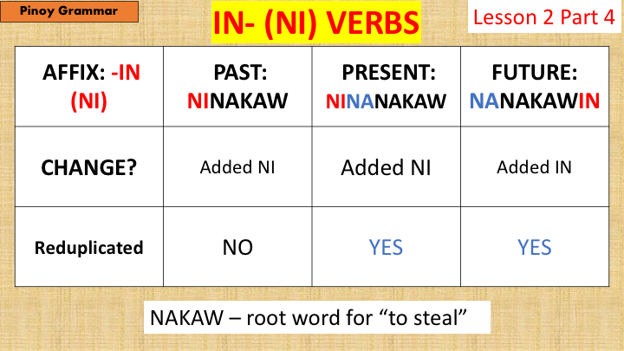
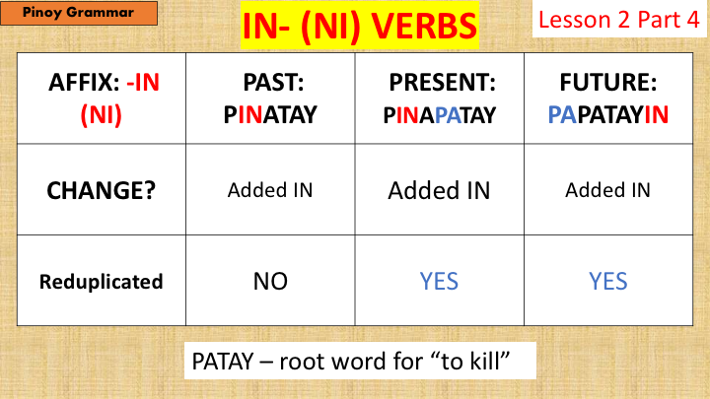
UM & IN Conjugation
See the other file named IN Verbs Filipino Grammar for more information.
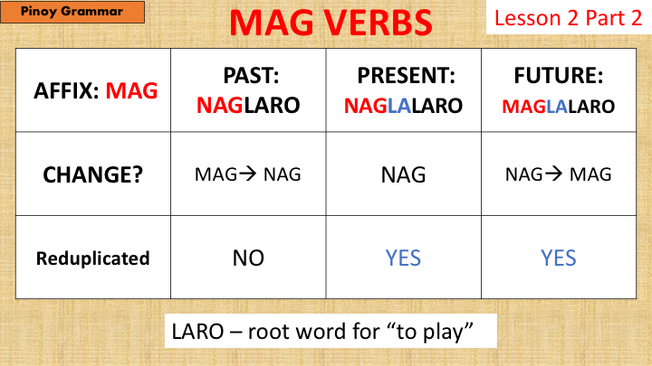

See the other file named MAG Verbs Filipino Grammar for more information.

